Parachutes

AIM
The aim of this experiment is to investigate the rate of fall of a simple parachute.
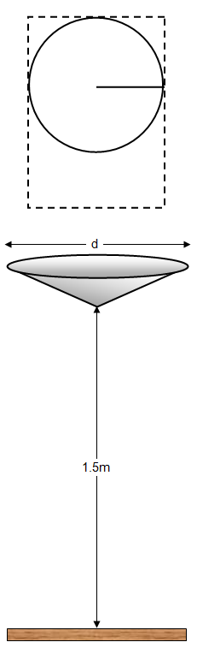
YOU WILL NEED
A sheet of A4 paper
A metre ruler
A stop watch or stop clock
Scissors
Sellotape
Pair of compasses

WHAT TO DO
Using the compasses draw the largest circle on your paper that you can. (If you don’t have compasses use a plate or other circular object). Mark the centre of your circle clearly with a dot.
Cut out the circle, draw a radius and then cut along this line to the centre.

Fold you circle round into a large angled cone and stick the edges to fix them in place. Measure the diameter of the open side of the cone (d)

Hold you cone parachute horizontally with its point 1.5 m above the floor, let it go and time how long it takes to fall to the floor (t). Repeat this three times to get an average time.

Now remove the sellotape carefully and twist the paper round to make a cone with a slightly smaller diameter and stick it in place. Do not cut any paper off – you want to keep it the same mass.

Drop the cone and time how long it takes to reach the floor again.

Repeat this for at least six different diameters of cones similar to the ones shown in the picture.

ANALYSIS AND CONCULUSION
Work out the diameter of your cone squared (d²) for each cone. Plot a graph of the diameter of your cone squared (d²) against the time of fall (t).

Write an account of your experiment and suggest a conclusion.

